Parent Letter



Mary Pack,

It was wonderful to meet with you and your son! To summarize our conversation, Jacob scored a standard score of 126 on the PPTV, which lands him in the 96th percentile of all 8-year-olds. As he is already above average in his vocabulary skills, I recommended that he continue
reading his chapter books and that you parents continue to encourage his literacy skills. This can be done by providing him books that challenge him a little, using descriptive vocabulary in everyday situations, and explaining new words with him. On the assessment, the words he struggled with most were unfamiliar nouns that he either hasn’t seen before or didn’t know was a synonym for something simpler that he’s already familiar with. But like we discussed, Jacob is in 2nd grade and is doing remarkable. Thank you for your time and support!
Daphne Pack

This letter reflects a student’s efforts to understand and implement child observation and assessment and is not an official diagnosis of your child’s actual development. Please see a licensed professional if you have questions or concerns about your child’s development.


Parental Consent for Individual Child Observation
I give my permission for my child, Jacob Pack , to be the focus child for
Daphne Pack , a student in the Brigham Young University-Idaho CHILD 350 course, for the purpose of learning about observation and assessment of child development and learning. During this time, the above-named student will perform formal assessments and observations of my child. I understand that my child’s name and other personal information will be kept confidential and all the information gathered will be used only for the purposes of assignments for this course. I understand that all information will be available to me and that I may ask questions at any time. At the end of the semester the above-named student will share what they have learned with me. I further understand that I may revoke my consent in writing for any reason. If I have questions or concerns, I may contact the above-named student’s instructor at the number below.


(printed)
Mary Pack
Parent’s Name


Date: 2/20/2026

Parent’s Signature

CHILD 350 Instructor Contact Information Shawnee Hendershot 496-4018 hendershots@byui.edu

Self Evaluation

I administered the PPTV assessment to my husband’s 8-year-old cousin who lives here in Rexburg. We were able to meet in person at his house with his parents and my husband present.
Overall, it went really well, but I think next time I would encourage everyone else to leave the room or everyone but his mom, because I think having three other adults silently watching him made him a little nervous. He was also just getting over a sickness so he was a little lethargic.
Ideally, I would administer this assessment when the child was more awake and upbeat. But even though he was mellow, he participated willingly and followed all the instructions. He also got a
fairly high score for his age. It also helped that instead of sitting at a table, we sat in the same

formation at the corner of their living room ottoman on the floor. This made it more casual and comfortable. The parent conference was short and sweet over the phone. We discussed the meaning of the scores, and I recommended that they keep doing what they’re doing. Next time, I think I’ll make more of an effort to be more official/professional and meet in person. It would also have helped if I understood the assessment scoring better.

Peabody Picture Vocabulary Test, Fourth Edition

Lloyd M. Dunn, PhD Douglas M. Dunn, PhD



ID#: ----------
-"--

)'c:1r fonrh D, a
�Jest Date 2l9 0� 4

Acltlrt">..;s:

1t \! :
•
I -----------------------

ZIP.
l l<J111l [)\1 nt:: -------------------
CurrenI Grade: '2,'<' ti\
c1 r l e I of
EdLlt:�1t1011 C 011111lL"led

Tertcl1er/Cou11�elc.lr:
Birth D,ttc \=r \ \
Age"
., 1)(1 not r11l1nd up

R a on for le.sti11g:
Score Summary
RAW SCORE
(From hox c111 page 1)

Graphical Profile

0.1 °/o -- -

...._.... _ 0.1°/o
Standard core
(Table D I, R 2. or B 3)
Confidence lnterval
-
Percentile
l f,thle n �,)

-----...------J_2.2� _!3.6� 34.110 /o __._ �.1°� !3...:_6°(< -1_2.2°/o_T _-:=_ - -_

-5S0 -4S0 -3S0 -2SD -1 SD Avg. +1SD 2SD +3SD +4SD
I I I I I I _J_ I· - t I ' - � I I I -I H- I , J_ - t- I -� f- ·t-
•
Non11..tl un·e Fquiv;.tlcnL (NCE)
(T,1ble B.4)

20 30
40 50 60 70 80 90 100 110 120 130 140 150 160
t _ I,_ 1-- --4 I_+- t ½ t-- -+- t-
, 2 5 9 16 25 37 50 63 75 84 91 95 98 99
Staninc
(T..1hlr B 4)

-----------t-j--t--1--rl- - 1 -- --t -�- ..j 1 -t -----
E
1 10 20 30 '10 SO 60 70 80 90 99
_l
- ...---....... - -· J
c;ro\vtl1 Scale \'alue (GSV)
l T.1hle n 5 l)f R 6)

tanin
1 2 3
4 5 6 7 8 9

- ,--_. -_ ,
_..._--r,_..
._, ,..._.

Reco n1111e11 dation�:
Extremely Low Score
Moderately I Low High I Moderately Low Score ; Average Score I High Score
Extremely High Score
Dt\ge E,1t11vale11t
(T.tl1l1.· B.'1)
□(�re Llc f�Lllli\1Jlt1\l
l labll' l\ o)




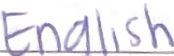





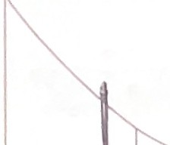
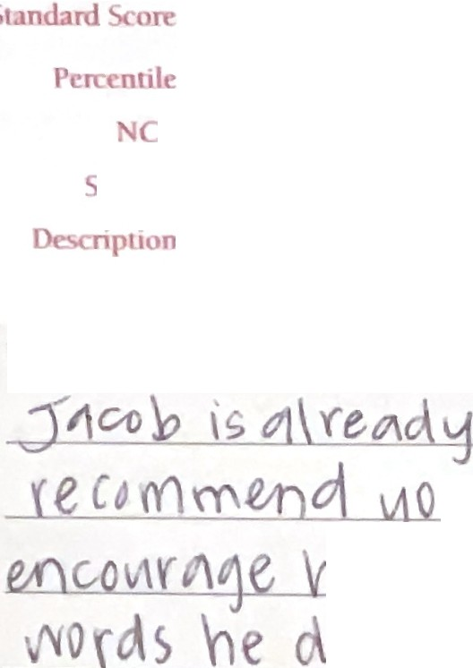


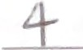

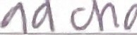
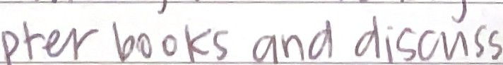

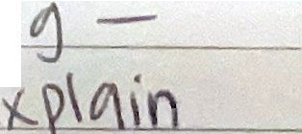
d\�o"e O\Ve-y-¢l�e, \n \o\S \/O(·�'oV\\".'.\'X) •SK<l\�.
NORMS USED:0
0
Age
Grade: F,1ll
D Grade: Spring
v\ v0Y1• n\At Plt 've 01, "'" , ...o\f\
- \o re
OtSY\. \- \::hew.

Copyr,gl,t c 1959, 1981, 1997, 2007
\\lascana Limit d Part., rsh,p. All nghts reserved Published and distributed e. clvstvtty by NCS Pearson, Inc

Product Number 3070 ( 2!5)
30708 (100)

Start Your Administration Here

Administering Items
1·J1t Training Items t11tt"-l l)c �ltl1111111',(crcti ft1·c;t. l)11ect1011s nr, Ii te,l t)n tl1c l1-ain1ng CL\�cl page .
·1l1�Start ltc1n 1� Il1e f1r�l 1te111 in l1,c agc-,1ppropri.:tte itc111'Ct �t,1rt ltc111s arc listed in tl1e rigl1t-ha11tl colum11 011 t l1i">p�lge. ,1nc.l on t11c tabheel ca1:,cl page!,.

Calculating the Total Number of Errors
Tra11�fer tl1c nL11nl1er of error"' per .set to the l1oxcs lJclo,", ,incl ,1dc.l 11p tl1e totc.11 errors. Be sure to LLSC tl1c lc;\vcst. Basal�ct and t l1e l11gl1est Cei Iing Set. See Chnptc1�2 of tl1e m,1nual for ft1rther details.

0

Training Items
All 1nstrt1ct1c,ns for i111rocltt ing th test ancl ad1n1ni5tcr1ng the Trai11ing ltcnis ar lc•catccl 1n Ll1c easel.

Tl1c Complete Set Rttlc 1·c4u1rcs the aclmin1stration of all 12 itcn1- in tl1c ct in order, bcgin111ng \Vith the fir�L i tc·rn 111 the �et.
Tl1c Basal Set Rule -1 011e ( l) orzero (0) errors in a

ct. E:-,Lablisl1 thr Ba�al Set first. l[ nec.cssaT), admini te1·

Set 1
Set 4 0

Set 7 0
Set 2
Set 5 0
Set 8 l
Sct3 �-
Set 6 _f2._

Set9 0
Set 12 ..

Training Page A
A1. boy | 1 | 2 | 3 | 4 | E
A2. chair | 1 | 2 | 3 | 4 | E
A3. puppy | 1 | 2 | 3 | 4 | E
A4. bike | 1 | 2 | 3 | E

earlier sctc; tlnLil the n\le is 111et or unt1l et 1 i ct1mplctcd. Tl1cn test for\.vard by sets until a Ceiling Set is obta111cd.
Set 13 ?j
Set 16 �
Set 15 6

After the exan11nee respo11ds correct\}' and w1tl1ot1t helJJ
to two Training Items, go Lo ltem 1. and begin te"ling.

The Ceiling Set Rule l5 eight (8) or n1orc errors in a
Set 17 /
Set 18 /
Set 19 /

set. Stop testing after g1,,,ing all ite1ns in the Ceili11g Set.

Recording Responses and Errors
- Record the C\.aminee's response ( l, 2,3,or4)on t11e recorc.lfom1 IJ)- circling Lhe corresponding nun1bcr
afLer the stim11ltts ,, ord for each itc1n. The correct rc�ponse ts i 11 red. See tl1c example belo'",·
- Indicate an error (incorrect or no response) b} drawing
an oblique line thro11gh the E, as�ho\vn below.

Example:
Total Errors
(b•t\1..ccn l\..1.s.11 C::,c1
.and (c1hng �Pl)

Calculating the Raw Score
Record tl1e number of the Ceiling Item, vvhicl1 is tl1e last item in the Ceiling Set. For exa111plc, if the exa1n1nces l1igl1esl Ceiling Set \vas Set 6, the Ceiling Item would be 72. Subtract from tl1e Ceiling ltem the total number of errors macle 1Jy the exa1ninee (from the Basal Set through tl1e Ceiling Set). Tl1e
result is the Raw Score. See Chapter 2 of tl1e n1anual for furthcr deta11s.

Age 2:6-3:11

Start Item 1

•

Ages 4 Through Adult
Training Page B
Bl. | laughing | 1 | 2 | 3 | 4 | E
82. | sleeping | 1 | 2 | 3 | 4 | E
83. | hugging | 1 | 2 | 3 | 4 | E
84. | walking | 1 | 2 | 3 |  | E

-
3

  - ball 1 2
4 E Ceiling Itcn1
\02-
After the cxaminec re"pond corrl'·ctt,, a11cl \i\·1thl)ttt

  - dog 2 3 4 E Total Errors - 26
-
help to two Trai11i11g lte1n , go to tl1t· appror)rtatc
Start ltc1n, an<l begin te�t1ng.

  - spoon 1 2 3 4

  - foot 1 2 4 E
Raw Score
Transfer this Ra\v Score Lo the record form cover.
Start Item | 13 | 37 | 49 | 61 | 73 | 85 | 97

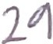


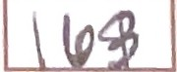

- ror eacl1�et, record the number of errl1rs 1n the box labeled "Number of ErTors.,,

2

' - -
Age 11- 12 13 14-16 17-18 19+

Start Item | 109 | 121 | 133 | 145 | 157

13.
pencil  cookie | 1  1 |  | 2 | 3 | 4 | E
 |  |  | 2 | 3 | 4 | E
drum 1 2 |  |  |  | 3 | 4 | E
 |  |  |  | 3 | 4 | E
turtle |  | 2
red | 1 |  | 2 | 3 | 4 | E

1-4.
spoon | 1
foot | 1
duck | 1
banana | 1
shoe | 1
cup | 1
eating | 1
bus | 1
flower | 1
mouth | 1

15.
-
16.
-
1 7.
18. .
� Jumping

1 2 3 4 E
- dancing  -- -  - whistle  -  - kicking | 1  1 | 2  2  2 | 3 | 4  4 |  | E  f  E
28. lamp | 1 | 2 | 3 |  | f
29. square | 1 | 2 | 3 |  |  | f
30. fence | 1 | 2 | 3 | 4 |  | t
31. empty | 1 | 2 | 3 |  |  | f
32. happy | 1 | 2 | 3
33. fire | 1 | 2 | 3 | 4 |  | E
34. castle | 1 | 2 | 3 |  |  | E
35. squirrel | 1 | 2 | 3 |  |  | E
36. throwing | 1 | 2 | 3


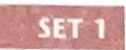


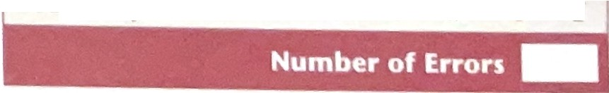
1 .
b
ti
1
3..
2
2
2
2
2
2
2
2
2
2
2
2
3
3
3
4
4
4
4
4
E
•
dog
E
-..-•
,)
6�
7.
8.
9.
10.
11.
12.
3
3
3
3
3
3
3
3
4
4
4

4
E E E E E E E
E
- 11,tl'litl Set Rttll·: c )111' <I) ,11 1l rc1 (()) ,., tl>ts 111 a r·t.
1n1n, ,, 111, tl,c t,, , ,, 1,1 111 tl,r Sl't
11\ 'fll r
p l:(C ..-.:I ,,1,: \(lltllllt,(c.'1 .tll 12 llt'll\S lll ,t,l-. set
- (

19. carrot 1 2 3 4 E
20. reading | 1 | 2 | 3 | 4 | E
21. toe | 1 | 2 | 3 | 4 | E
22. belt | 1 | 2 | 3 | 4 | E
23. fly | 1 | 2 | 3 | 4 | E
24. painting | 1 | 2 | 3 | 4 | E


37.
38.
39.
40.
41.
42.
43.
44.
45.
46
47.
48.
farrr1 pengui•n gift feather cobweb elbow juggling fountain net shoulder dressing
roof
1
1
1
1
1
1
-1
1
1
1
1
2
2
2
2
2
2
2
2
2
2
2
2
3
3
3
3
3
3
3
3
3
3
3
3
4
4
4
4
4
4
4
4
4
4
4
4
E E E E E E
E
--
E
•
E E E
E
49. peeking |  | 1 | 2 | 3 | 4 | E
50. ruler |  | 1 | 2 | 3 | 4 | E
51. tunnel |  | 1 | 2 | 3 | 4 | E
52. branch |  | 1 | 2 | 3 | 4 | E
53. envelope |  | 1 | 2 | 3 | 4 | E
54. diamond |  | 1 | 2 | 3 | 4 | E
55. calendar |  | 1 | 2 | 3 | 4 | E
56. | buckle | 1 | 2 | 3 | 4 | E
57. | sawing | 1 | 2 | 3 | 4 | E
58. | - panda | 1 | 2 | 3 | 4 | E
59. | vest | 1 | 2 | 3 | 4 | E
60. arrow |  | 1 | 2 | 3 | 4 | E

61. picking |  | 1 | 2 |  | 4 E
62. target |  | 1 |  | 3 |  | 4 | f
63. dripping |  | 1 | 2 | 3 |  | 4 | f
64. knight |  |  | 2 | 3 |  | 4 | E
65. delivering |  | 1 | 2 | 3 |  | 4 | E
66. | cactus | 1 | 2 |  |  | 4 | E
 |  | 1 | 2 | 3 |  | 4 | E
67. | dentist
68.
-
69.
 | floa-ting | 1 2 3 f.
 | claw | 1 2 3 4 E
70.
 | uniform | 1 | 2 | 3 |  |  | E
71. gigantic |  | 1 | 2 | 3 |  | 4 | E
72. furry |  | 1 | 2 | 3 |  |  | E


3

- Complete Set Rule: dmini�tcr nil 12 it n1s in Ll1c cl
in rder, tarting with tl1e fir l ite111 i111l1 et.
- Basal Set Rule: 011e (1) or zero (0) errors in a et. • Ceiling Set Role: ight (8) or more errors in a set.

- violin 2 3 4 85. hyena 1 2
3 E 97.
pi•geon
2 3 4 E

- group 1 4 E
- globe 1 2 3 4 E
- plumber 1 2 3 4 E 98. ankle 1 3 E
  - flaming 1 2 3 4 E
2
1
87. ri•ver
4 E
4

- vehicle 1 2 3 4 E
101. aquari•um
88.
ti•mer 1 2
  - wrench 1 2 3 4 E

chef
1 2 3 4 E
89.
catching
1 2 3 E
1 2 3 4 E

- squash 1 2 3 E
- ax 1 2 3 E
80. flamingo |  | 1 |  | 3 | 4 | E
81. | chimney | 1 | 2 | 3 |  | E
- trunk 1 3 4 E
- vase 1 2 3 E
 | 2 | 3 |  | 4 | E
 | 2 | 3 |  | 4 | E
2 |  |  |  | 4 | E

92.
harp
2
3
4
E
- bloom 1 2 3 4 E
- refueling 1 3 4 E
- safe 1 2 3 4 E
- boulder 1 2 4 E
- reptile 1 3 4 E

82.
sorti•ng 1
- horrified 1 2 4 E 106.
canoe

1 3 E

83.
wai•st 1
3 4 E 107. athlete 1 2 3 4 E

84. vegetable 1
2
1
swamp
95.
96. heart 1 2 4 E 108.
towi•ng
2 3 E

- luggage 1 3 4 E

121.

1• nterv1•ew1• ng

2 3 4 E 133.

inhaling 1 2 3 E

- directing 1 3 4 E
I
122. pastry 1 2 3 E 134. links 1 4 E

v•ine
1 2 3 4 E
123.
ass1•st1• ng
1 3 4 E 135.
polluting 1 2 4 E

- digital 1 2 4 E
E
E 136. archaeologist
1 2 3 4 E

- dissecting 1 2 4 �
137. coast 1 2 3 E

- predatory 1 2 3 4 E
E 138.
1• n•1ect1• ng
2 3 4 E

- hydrant 1 2 3 E 127. puzzled 1 2 3 4 E
2
1
mammal
140.
124. fragile | 1 | 2 | 4
125. solo | 1 | 2 | 3
126. snarling | 1 2 3

139. fern 1 2 3 4 E

- surprised 1 2 3 4 E
�
- beverage 1 3 4 i 4

- palm 1 3 4 2
- clarinet 1 3 4
- inflated 1 2 3 4 E
- tusk 1 2 3 4 E
- demolishing 1 2 4 E

- isolation 1 2 3 E

- valley 2 3 4 E
- kiwi 1 2 3 E
- trumpet 1 2 4
- rodent 1 3 4
- clamp 1 2 3 4 E
- dilapidated 1 2 3 E


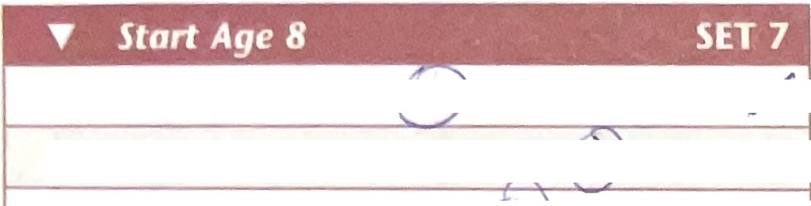
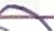

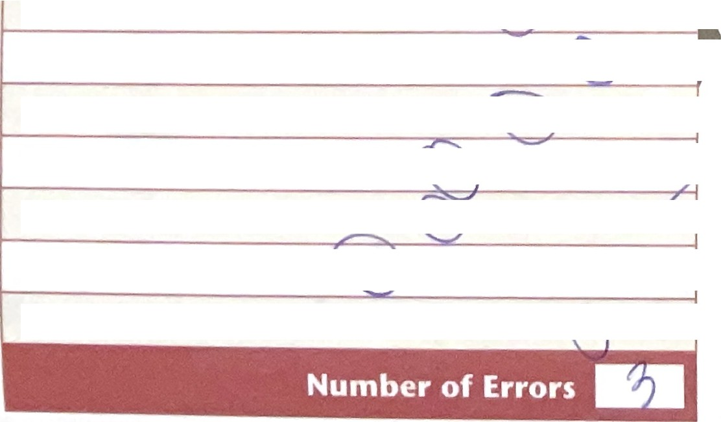

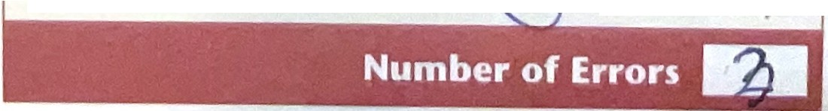
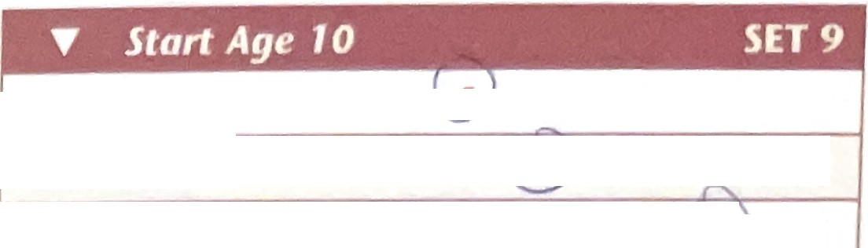
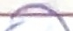
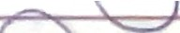

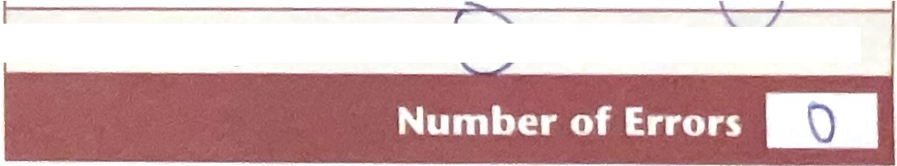
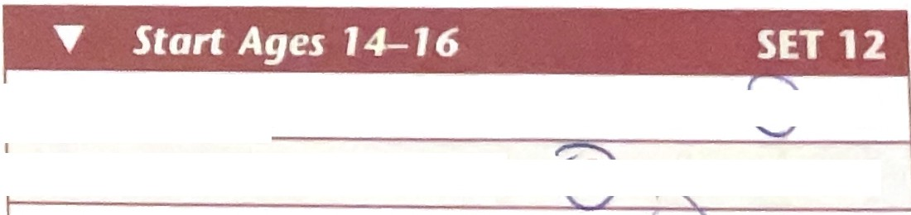


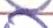


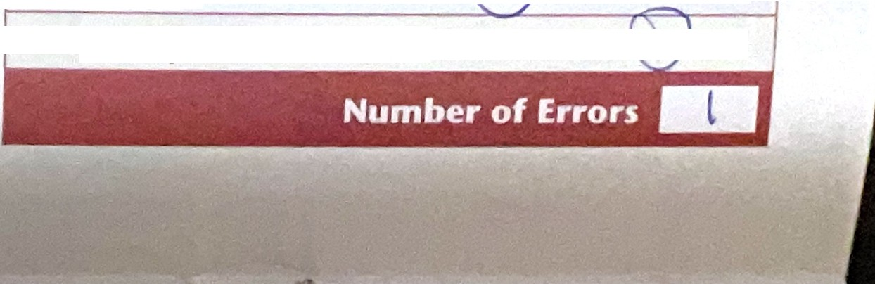

4

, s ,#

- Complete Set Rule: Administer all 12 iten1s in the seL
In order, starting witl1 Lhe fir t ilern in the seL.
- Basal Set Rule:
ne (1) or zero (0) errors in a et.
- Ceiling Set Rule:
ighL (8) or more errors in a seL.

d 169. hazardous 1 2 3 4 E
145. pedestrian 1 |  | 3 |  | 4 |  |  | 157.
146. 1• nter1• or | 2 | 3 |  | 4 | E |  | 158.
147. garment 1 | 2 | 3 |  | 4 | E |  | 159.
148. departing 1 |  |  |  | 4 | E |  | 160.
149. feline 1 | 2 | 3 |  | 4 | E |  | 161.

primate | 1 |  |  | 3 | 4
glider | 1 |  |  | 3 | 4
weary | 1 | 2 |  | 3
hatchet | 1 | 2 |  |  | 4
transparent | 1 | 2 |  |  | 4

r
170. | pentagon | 1 | 2 | 3
171. | appliance | 1 | 2 | 3
172. | poultry | 1 |  | 3 | 4
173. | cornea | 1 |  | 3 | 4 | E

z

E

150. hedge 1 2 3 4 E
151. c•itrus 1 |  |  |  | 3
152. florist | 1 | 2 3

162. sedan 1 2 3 4
- peninsula 1 2 3 4 E

4 E 163.
constrained
1 2 3 4 E
- porcelain 1

3 4 E


4 ,t'
- hovering 1 2 3 4 E
- aquatic 1 2 3 E
- valve 1 2 4 E
- parallelogram 1 2 3 t
- pillar 1 2 3 4 E
- detonation 1 3 4 E
- cerebral 1 3 4 r'

- perpendicular 2 3 4

155. reprimanding |  | 2 | 3 | 4 | E
156. carpenter | 1 | 2 |  | 4 | ,,/

consumi•ng
1 2 3 4 E
- submerging 1 2 3 4 E

currency
1 2 4 E

syri• nge
1 2 3 4 E

- lever 1
- apparel 1
- talon
- cultivating
- wedge 1
- ascending 1

Continue on page 6
2  2 | 3 | 4 | .,f
 |  |  | ..e
2 |  | 4 | E
2 | 3 | 4 | E
 | 3 | 4 | f'
2-

- depleted
1 3 4 I

- sternum 1 2 3 ff

mar1•t1• me
1 2 3 4 E

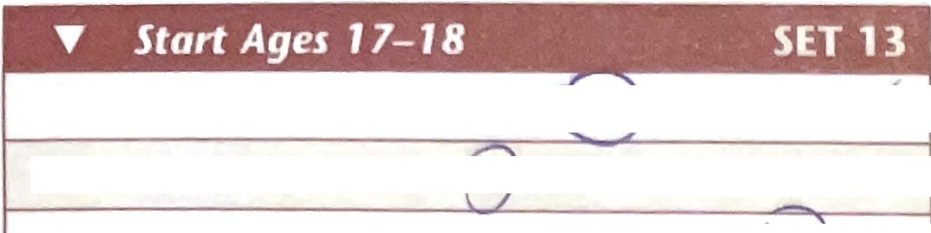
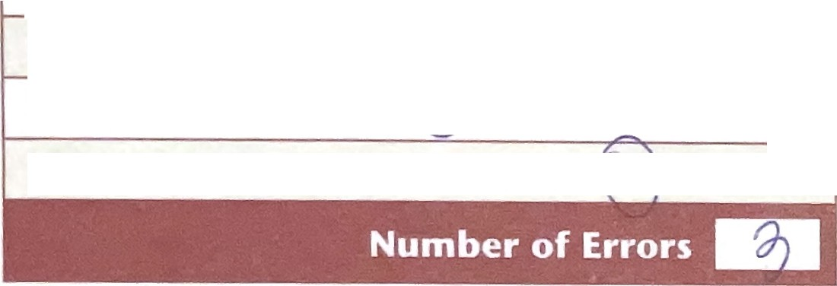
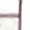



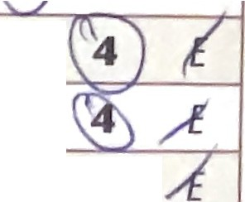

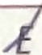
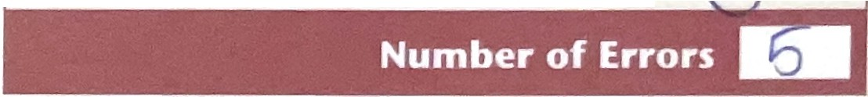
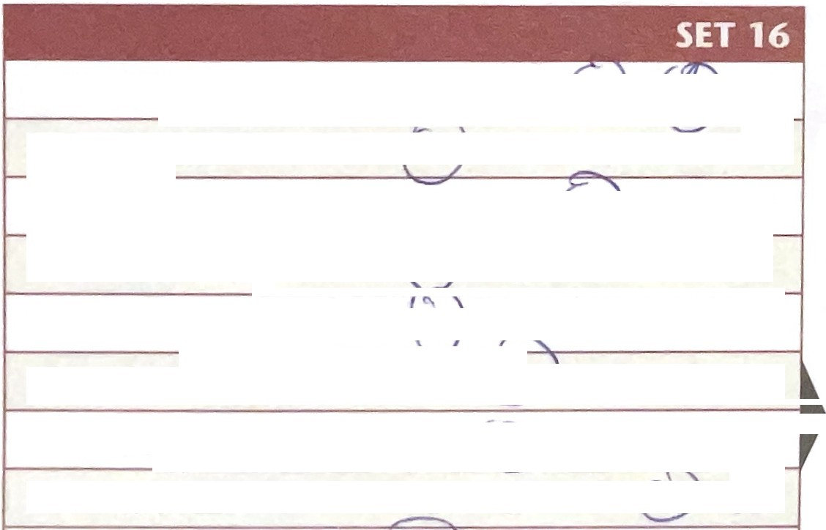
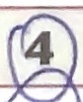
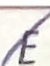
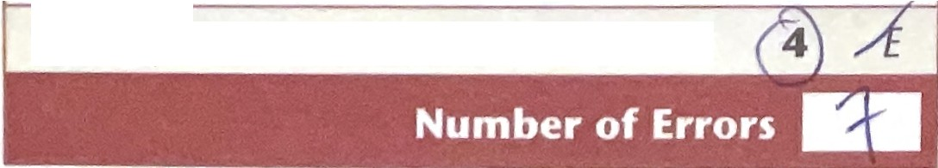
- incarcerating 1 2 3
E
- dejected 1 2 3 4
- quintet 1 2 3

5



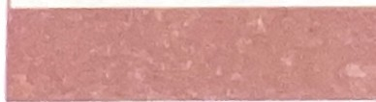

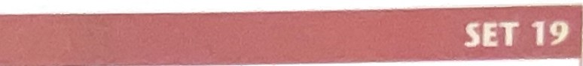

(MURkuhn t I)
-
208.
209.
210.
[r1POHZ ing]
211. cupola
1
3
4
E
212.
-
derrick
[DER 1k-)
convex
[kon VEKSJ
[KYOO puh luh]
1
2
3
E
213.
1
2
3
4
E
{AN gluhr]
(DROt\1uh da r ee]
223.

224.
caster
[KAS tuhrj
terpsichorean
[tut1rp s1k uh REE uhn}
cenotaph
(SEN uh t1-f]
1
2
3
4
E
1
2
3
4
E
-
225.
1
2
3
4
E
[ton SOHRee uhll
217. legume  (LE g}oomj |  | 1 | 2 | 3 | 4 |  | E
218. cai•rn |  | 1 | 2 | 3 |  | E
[KAYRN]
219. arable 1 2 3 4 E
[AYR uh buhl]
220. | supi•ne | 1 | 2 | 3 |  |  | E
 | [suu PIYNj
221. | vitreous | 1 | 2 | 3 | 4 |  | E
 | (VI lree uhs]
222. lugubrious  [luu GOO bree lJt'\s1 |  | 1 | 2 | 3 | 4 |  | E

wildebeest 1 2 3 4 E
fWIL duh be \tJ
coniferous 1 2 3 4 E
[koh NIFuh ruhs]
timpani 1 2 3 4 E
l Tl�1p-ul1nee]
pilfering 1 2 3 4 E
lPILFuhr ,ny]
pestle 1 2 3 4 E
[PE suhl]
reposi•ng | 1 | 2 | 3 | 4 | E

193. incandescent | 1 | 2 | 3 |  | E | 205.
[,n uhn DES uhnt]
194. confiding  1lruh.r1 Fl)'D 111g] |  | 2 | 3 | 4 | E | 206.
195. mercantile | 1 | 2 | 3 | 4 | E | 207.

196. | upholstery | 1 |  | 3 |  | E
 | [uhp rlOHL stuh ree]
197. | filtration  lfil TRAY huhnl | 1 | 2 | 3 | 4 | E
198. | replenishing | 1 | 2 |  | 4 | E
 | [ fl Pl[ nish ,ng]
199. | trajectory |  | 2 | 3 | 4 | E
 | (trut1 IEI<tuh reej
200. | perusi•ng | 1 | 2 | 3 | 4 | E
 | [puh ROOZ 1ngJ
201. | barb | 1 | 2 | 3 | 4 | E
 | (BARB)
202. | convergi•ng | 1 | 2 | 3 | 4 | E
 | {kut1n \'Ut-lRJ1ngJ
203. | honing | 1 | 2 | 3 |  | E
 | IHOHN 1r19J
204. | angler | 1 | 2 | 3 | 4 | E

214. | embossed | 1 | 2 | 3 |  | E | 226. | calyx
 | (im BAWSTJ |  |  |  |  |  |  | [KAYhk.,j
215. | torrent  [TOHRlJhnt] | 1 | 2 | 3 | 4 | E | 227. | osculating  [OS k}1Uh IJyl 11,9l
216. | dromedary | 1 | 2 | 3 | 4 | E | 228. | tonsorial

1 | 2 | 3 | 4 | E
1 | 2 | 3 | 4 | E
1 | 2 | 3 |  | E

- o=p Ie I c .. t Ru Ic.: \ d111inI l r . ll l 2 it 111-., 1n l11  ,n rdcr. tart 111l ,, 1111 Ll1 1rst lt 1r1 in th""l:t | ct | - Ba al Set Rule: On (1) (lr zer | (l)) �Jr r.. in as | t. | - Ceiling cl R11le: ..1gl•t ( ) or n1 r | rr rs In • .....-,

Pronunciation Key
ay = long a | U= | hort u | oo as in /ooi | ee-= lonq e | j = sott g | llh as in sl1ove | iy = long i
g = hard g | oy as,• n co111  a = st1ort ii |  | oh= long o  ow as in loud | s = soft c | ar as in fr1rm | yoo = long u | k = hdrd c
uhr as ,n circle |  |  |  | ir as1n cl1eer | e = short e | aw as ir1 law | ayr c1s in chair
i = short i | uu as in foot |  | ohr a�1n }/Jore | o = �hart o
Nole: CAPS within pront,nciation indicale primary slre.ss.

6

u •

Classification by Part of Speech for the Peabody Picture Vocabulary Test, Fourth Edition (PPVT"'-4), Form A
Direction : 11 le 1l1c 1L·n111L1n1IJ • J ll11cltl\V c;1 a11d l·11gl1 s1 rr'Vl-4 11cn1 ;t l1111111sLercd ·or 111 oJTc L rcspl1n.t's, Llr, w a line througl1 th p n
bo to ti,, ngl1t of Ll1c 1tcn, 11un1I er Tall• .ind sum cath atcgo L' lt1m11. ll1c11, write 1l1c 11L,1ls l)y cr1Lcgory for# T,,k n an<l # lncorrc t 1n I h summ. ry bo, Lo the ngl11.

ti Ta/re,, _ 5°
  - 1nco11a,t 2

.Il,l
..
.Il,l
.Il,l
.Il,l Ill
;;;;..
.Il,l

C
:::I
..a.
.-:aI
C
:::I
..a.
.:aI
'C
C
:::I
..a.
-.:aI
C
:::I
:I
..a. -..
.a
C
:::I
.a .-�.a.
C
:::I
:I
..a. -..
.a

z0 Ill t
..
>
z0 Ill t
0 Ill t
0 Ill t
0 Ill t
0 Ill t

<
1 39
2 40
- < z
77
78
- < z
115
116
- < z > < z
153
154
- <


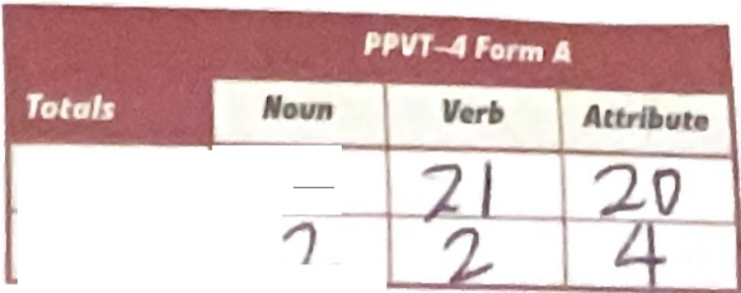
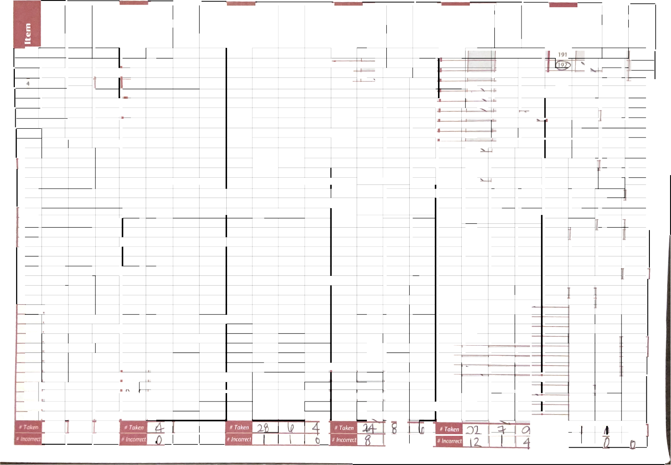
3
..

5
6
7
8
9
10
11
12
13
14
15
16
17 18
19
20
21
22
23
24
25
26
27
28
29
30
31
32
33
34
35
36
37
38
41 79
42 80
43 81
44 82
45 83
46 84
47 85
48 86
49 87
50 88
51 89
52 90
53 91
54 92
55 93
56 94
57 95
58 96
59 97
60 98
61 99
62 100
63 101
64 102
65 103
66 104
67 105
68 106
69 107
70 108
71 109
72 110
111
74 112
75 113
76 114
117
118
119
120
121
122
123
124
125
126
127
128
129
130
131
132
133
134
135
136
137
138
139
140
141
142
143
144
145
146
147
148
149
150
151
152

0 0
155
156
157
158
159
160
161
162
163
164
165
166
167
168
169
170
171
172
173
174
175
176
177
178
179
180
181
182
183
184
185
186
187
188
189
190
193
194
195
196
197
198
199
200
201
202
203
204
205
206
207
208
209
210
211
212
213
214
215
216
217
218
219
220
221
222
223
224
225
226
227
228
# Taken I
# Incorrect

Comparison of PPVT'·-Ill andPPVT-4 Scores Over Time
•

□A DB
0B
□A
□A
□A
□A
□A

□A
□A OB
0B

OB

0B

0B

0B
□A 0B
□A DB
□A OB

□A OB

0 Age

0 Age

□ Age

□ Grade: Fall
0 | Age | 0 | Grade: | Fall | D | Grade: | Sprir1g
0 | Age | D | Grdde: | Fall | D | Grade: | Spring
0 | Age | 0 | Grade: | Fall | D | Grade; | Spring

0 Grade: Fall

0 Grade: Fall

D Grade: Spring

D Grade: Spring

D Grade: Spring

(T bl B 7)

- Do not compare standard scores across editions (I.e., PPVT-111and PPVT-4 scales). GSV scores may b compared acrosi editions.

Using GSV Scores to Measure Change

15 20 30 so 60 70
I
I t
I
0 90 100 110 120 130 1SO 160 170 180 190 200 210 220 2.30 240 250 2.60 270 275

����
I
'. ��
I
im
L
. f
I•
!
I I
I
I
l
I
'
I
H
··tt-
I
#ffi

L
I
#I
r
l.
I T
.. J
I I
'.

�L

••

I I 1 I I i I I I i I I I I i I I
I
►
1{
1. l
1

I•

Tl1c t \,.,...ro,, th s ale \ al11e) cort: 1s designed for ml::, urtng l1:1nge o\·er t1n1... l_1ke a ra\,, core, the S SLu re I a111ncl1cator of ab oluLe, not relat1\·e1
p rfor111a11 e If a11 e.xam1nee's, o-abular) 1,1creases,
his or h r G \ '-ttl)f , 111111 reac:e. Tl1c GS\ '>Cale 1s like a ard tick,,,11d plotli11g G V s ores o,,er t1r11 an ll ,Lal }10,\ 1l1e exan11nee's ,,ocabul::iry perforr11ance h�1s cha11geJ
The sta11d t\.l s 01° s T\tS a cl11Ter nt p111p{)')(', wl11ch
1s t l\'.II h ,v th ·aml11ce SC(1rc cor11p�1res \\1th
1he .. ,·l:rJg co1e at a partILUlar ,1ge Ir 1s a 11 lpful
�upplen1er1t to tl1e (1,\ \.\1l1cn e\'aluaL1ng change. lf an cxan1111t.:c::> sLandard 5cores are the same on both
LlCLac;1ons, then tt1c cxam1nce's ,·ocabulary pertorrnance l1a 1ncrca<,cd at the a, erage rate for that age. If tl1c standard 5Core decline':, fro111 Lhe hrst testing Lo the next, the exam1nec still n1a} ha\ e 1111pro\ed 1n vocal)ttlar, kr10\vledge (as "ho\\ n b}' a l11gher G 'v), but Lhe rate of growth \Vas bc:low J\'etage.
Refer le) Appendix G 1n the PPVT-4 NlJ11ual for turtl1c1· 1nfom1,1t1on 0111ntcr111rt1ng ch,1r1gc 1n GS\ '.:>core .
To use the (, \, ·yard Lick tc,�how changr�1n perlL)rrnance O\er time, Ctln1plete the followin tep
1. \Vr1tc a _cqucnc.e nun1her ne..xLto lhe G Vs ore
of c<1ch PP\'T-lll and PP\l -4 adn11111-..lrat1 n you entered on this p:ige, st..trt1ng \ 1th l for th· earli--t adn1in1 LrJtton.
2 �1ar k the potnt., (ln the lJ�\ y..trd tick C()rre pl1nd111g tl) �-llh LS\ c >re.
3. \\/nt the corr" p(111d1ng ,tdn11ni trat1011 "'LtlUt11 c
nun1hl:rnextto ·n·l1n1a1kontl1t L" yarc.t t1 k






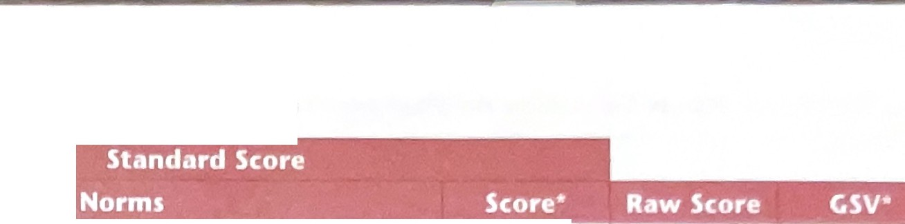



PsychCorp Is an imprint of Pearson Clinical Assessment. � p hCor
Pearson Executive Office 5601 Green Valley Drive Bloomington, MN 55437 800.627.7271 www.PsychCorp.com www.SpecchandLanguage.com � syc P.
warning: No part of th,s publlrat,on may b reproduced or transmitted 1n any form or by any means, eleclron,c or mechanical, 1ncludtng photocopy., , cording, or any lnformat1an stor ge and retrieval system, without perm1c.c;1on ,n wr1t1ng from the copynght owner.
Pearson, the PSI logo, and PsychCorp art: trademarks 1n the U.S. and/or other countr,e� of Pearson Education, Inc., or ,ts affihate(s).
PPVT 1s a trad mark of Lhe Wac;cana L1m1ted Partnership.
Printed 1n the Unit d States of America
24 ABC OE

